**Distance Measurement of Object using Ultrasonic Sensor**

PBL-II Project Report submitted to Savitribai Phule Pune University, Pune



In partial Fulfillment for the awards of Degree of Engineering in Computer Engineering

**Submitted by**

**Mr. Soham Chinchalkar Exam Seat No. S190244262**

**Ms. Madhura Sobalkar Exam Seat No. S190244477**

**Mr. Yogeshwar Patil Exam Seat No. S190244421**

**Mr. Kartik Katakdound Exam Seat No. S190244336**

**Under the Guidance of**

**Mrs. Ashwini Dhoke**

**Assistant Professor**

**Department of Computer Engineering**



**Dr. D. Y. Patil Institute of Technology,**

**Pimpri, Pune-411018**

**May 2021-22**

**Certificate**

This is to certify that,

Soham Chinchalkar Exam seat no: S190244262

Madhura Sobalkar Exam seat no: S190244477

Yogeshwar Patil Exam seat no: S190244421

Kartik Katakdound Exam seat no: S190244336

have successfully completed the PBL II project “**Distance measurement system of object using ultrasonic sensor**”under my guidance in partial fulfillment of the requirements for the Second Year of Engineering in Computer Engineering under the Savitribai Phule Pune University during the academic year 2021-2022

**Date: ………….**

**Place: ………….**

**……………………………….**

**Mrs. Ashwini Dhoke**

**Assistant Professor**

**Project Guide**

**Dr. S.V. Chobe**

**Head,**

**Department of Computer Engineering**

**Acknowledgements**

With a deep sense of gratitude, we would like to thank all the people who have lit our path with their kind guidance. We are very grateful to these intellectuals who did their best to help during our project work.

It is our proud privilege to express a deep sense of gratitude to **Prof. Dr. Pramod Patil,** Principal of Dr. D.Y. Patil institute of Technology, for his comments and kind permission to complete this project. We remain indebted to **Dr. S. V. Chobe,** H.O.D.Computer Engineering Department for his timely suggestion and valuable guidance.

The special gratitude goes to **Mrs. Ashwini Dhoke** excellent and precious guidance in completion of this work. We, thanks to all the colleagues for their appreciable help for our working project. With various industry owners or lab technicians to help, it has been our endeavor throughout our work to cover the entire project work.

We are also thankful to our parents who provided their wishful support for our project completion successfully. And, lastly, we thank our all friends and the people who are directly or indirectly related to our project work.

Mr. Soham Chinchalkar

Ms. Madhura Sobalkar

Mr. Yogeshwar Patil

Mr. Kartik Katakdound

**Abstract**

A distance detector is any device capable of measuring the distance between two points. The origin the distance between two points. The origins of distance measurement by means of graduated lengths of material such as chain, tape measure. Basically, this ultrasonic technology is based on ultrasound and a common use of ultrasound is in range finding that perfectly related to the objective. Properties of ultrasonic waves like reflection, transmission over large distances with no appreciable loss of energy make it suitable for distance measurement. Ultrasonic waves are suitable for both air and underwater. The accurate measurement of distance is major subject of study in the field of engineering and technology. Employing electromagnetic waves for distance measurement gathered significance with the advent of research in the field of electromagnetism. The objective of this paper is to develop a device that can be used to measure a distance with high accuracy by ultrasonic sensor HC-SR04 using 89S52 micro controller. The range of 2cm to 4m with a resolution of 0.3cm is measured using HC-SR04 ultrasonic transducer. For contactless measurement device has to rely on the target to reflect the pulse back. The ultrasonic range detector that uses Parallax’s PING >>> ultrasonic sensor gives better performance ultrasonic sensor can able to detect range of 2cm to 2.5m with accuracy of 0.1cm.

**Table of Contents**

**Abstract**

**List of Abbreviations**

**List of Figures**

**List of Tables**

**1** **Introduction**

1.1 Overview

1.2 Aim/Motivation

1.3 Objective

1.4 Organization of report

**2** **Literature Survey**

**3 Problem Statement**

**4. Software Requirements Specification**

4.1 Hardware Requirements

4.2 Software Requirements

**5. System Design**

5.1 System Architectural Diagram

5.2 GUI of Working System

**6. Conclusion**

**7. Future Scope**

**References**

1. **Use-case Diagram**

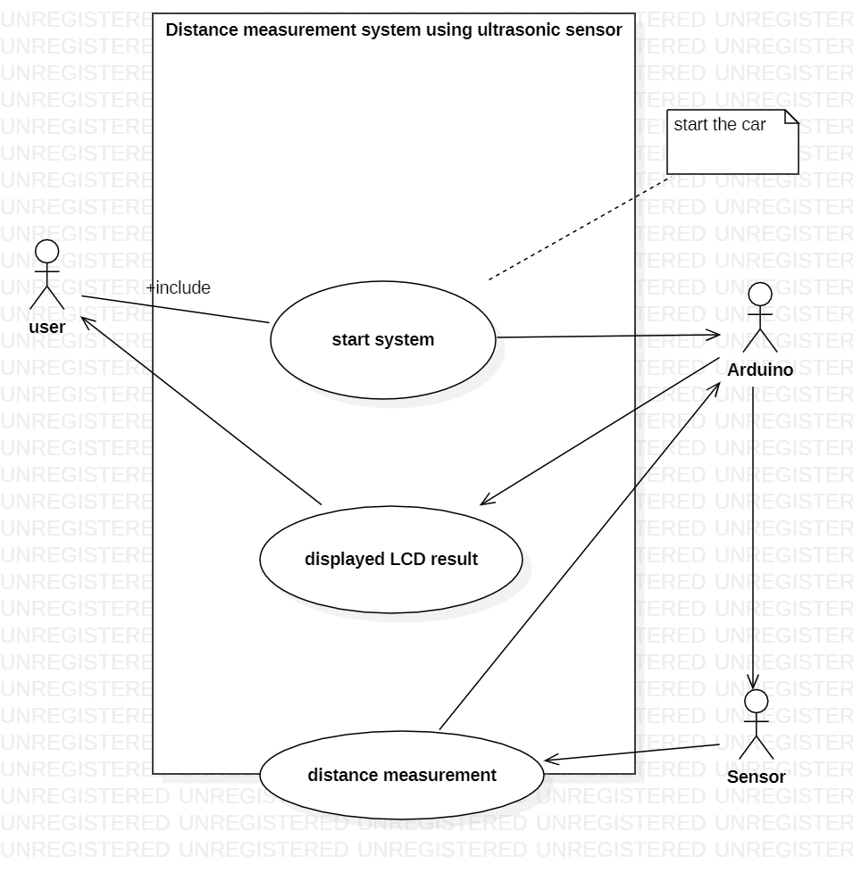

**2. Class Diagram**

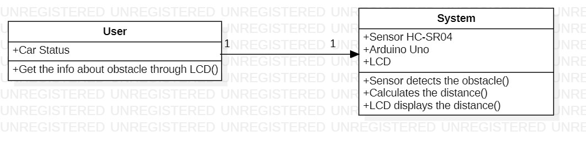

1. **Activity Diagram**

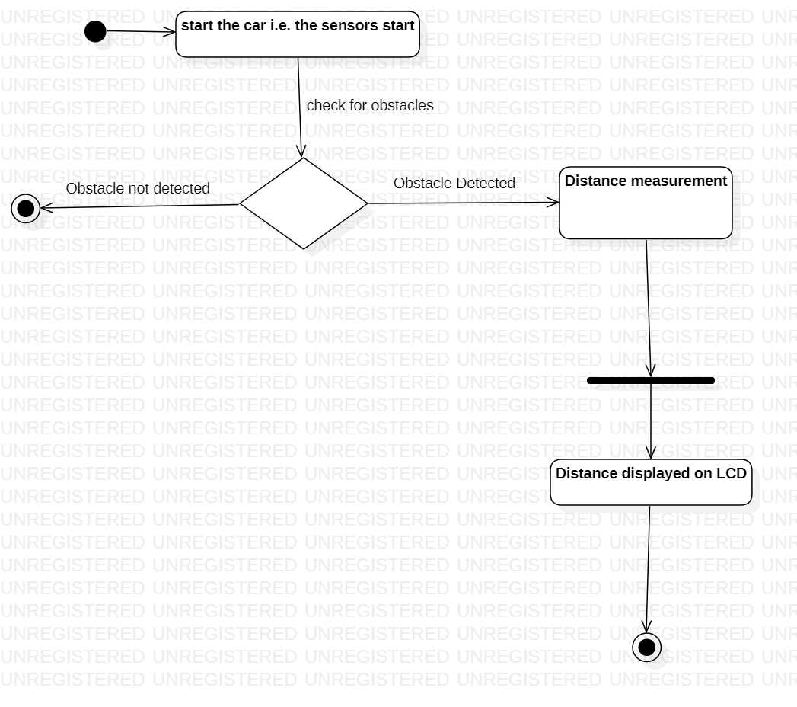

1. **Sequence Diagram**

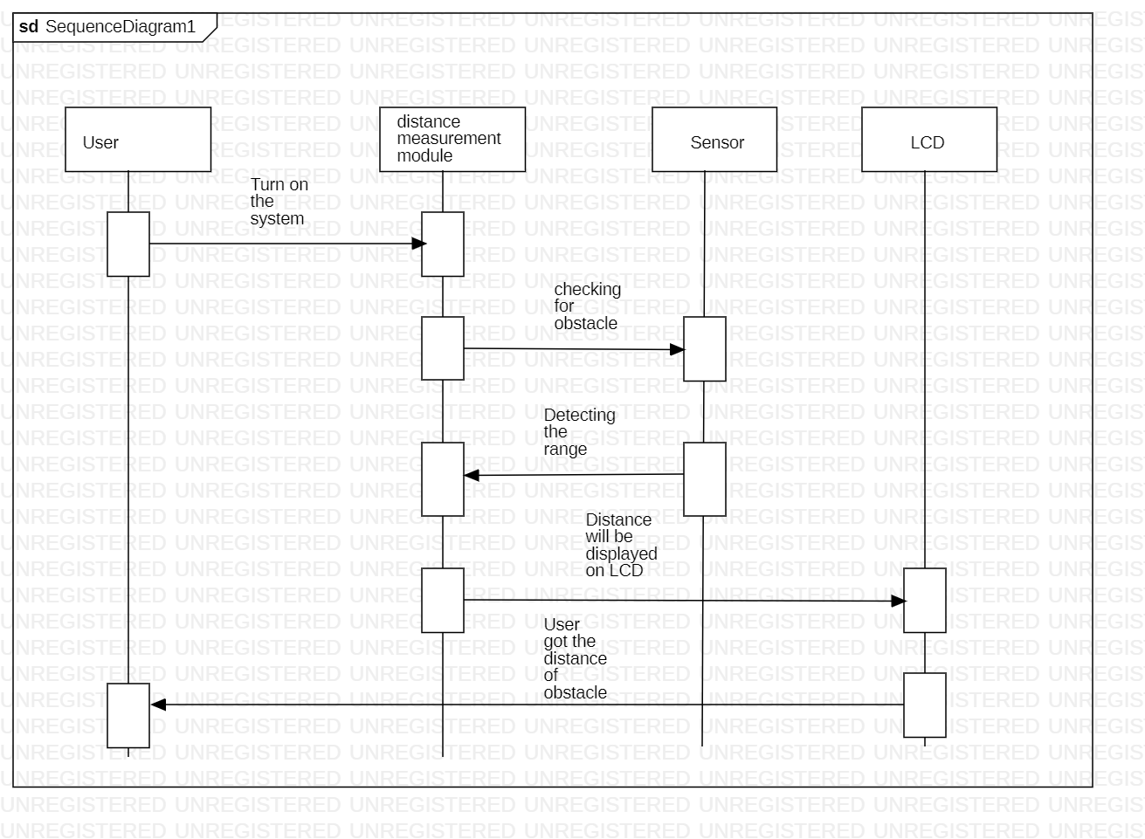

1. **Introduction**
   1. **Overview** –

The system consists of ultrasonic sensor HC SR04, 16x2 LCD display and Arduino uno. The distance from the obstacle is detected by the sensor and result calculated on Arduino is displayed on the LCD.

**1.2 Aim/Motivation -**

Nowadays, we have some difficulties in obtaining the distance that we want to measure. Even though, measuring tape is an easy option, but this kind of tool will have a limitation of manual error. Before this, engineers have produced a range finder module but, in the end, they find out the module have many disadvantages like limitation for distance, different result for different coloured obstacles, and need a calibration for every time before starts using it. Manual distance measuring is always done at the expense of human error. Precise and fix measurement of low range distance, is the main objective for this project. So, to solve the problem of distance measurement and to get accurate value this project is used to measure distance using ultrasonic sensors.

**1.3 Objective -**

The main objective of the project is to provide useful and low-cost measurement system that is easy to configure and handle.

- Precise and fix measurement of low range distance

- To measure a distance at any obstacle.

- Operating range of 0.5m up to 4m with an accuracy of 1 cm.

**2. Literature Survey -**

|  |  |  |
| --- | --- | --- |
| **S. No.** | **Author** | **Description** |
| **1** | Manpreet Kaur, Jai Pal  **(2019)** | There are several ways to measure distance without contact. The selection of distance measurement sensor in order to apply it in any application is very important to avoid any invalid experimental results. Measurement using ultrasonic sensor is cheapest among various other options. The paper proposed to build an efficient module that consists of ultrasonic sensor HC-SR04 with 89s52 microcontroller for distance measurement. This device make the use of microcontroller for calculation of distance and displaying the obtained results on LCD The experimental setup and result are described. And sensors’s maximum range of object detection is 4m. |
| **2** | Mohammed Sufyan MOHAMMED  **(2017)** | In this paper, a prototype of distance measurement and object detection system was designed and implemented successfully using Zigbee technology and ultrasonic sensing technology. This system can monitor a particular area and detect the location, direction and distance of the object that comes its way and convert it into a model that can be visually represented. This system was developed by using XBee chip which enabled the transmission of the information wirelessly, giving the system the ability to monitor an area away from the control room. Many tests were conducted on the designed system with one or more than one object at different distances and orientations, the tests included a moving object also. The readings were in close margin to reality and the obtained error proved to be negligible. The 1717 employment of XBee module for the transmission of sensed data between the system nodes presented advantage such as security and low power consumption to the system while covering a wider range as compared to other communication technologies. In addition to that Zigbee protocol and XBee module allows the implementation of several nodes at different locations which can be further developed or modified according to the arising needs. The proposed system can be used in robotics systems to avoid obstacles and collisions, automated guided vehicles, finding the depth or level of any medium and measuring general distances, etc. Moreover, the proposed system can be used in areas that are inaccessible to humans and also in areas where there is a risk to their lives. We can enhance the proposed system in the future by increasing the range of objects detection, by utilizing a fully 360 degrees rotational servo motor and also by mounting surveillance webcam to it which turns on when an object is detected. Further modifications, the proposed system could be a mobile robot system capable of avoiding obstacles or detecting objects and measuring the distance at the same time. Internet of things technology serves well in such applications. It can be integrated into the proposed system, and so the sensed data can be monitored using a smartphone remotely. Although it is outside the scope of the research work, it also looks like a possible extension in the future. |
| **3** | Prakhar Shrivastava, Praveen Kumar, Ankit Tiwari  (2014) | Nowadays, we have some difficulties in obtaining the distance that we want to measure. Even though, measuring tape is an easy option, but this kind of tool will have a limitation of manual error. Before this, engineers have produced a range finder module but in the end, they find out the module have many disadvantages like limitation for distance, different result for different coloured obstacles, and need a calibration for every time before starts using it. Manual distance measuring is always done at the expense of human error. Precise and fix measurement of low range distance, is the main objective for this project. This device can measure distance in the range of 0.5m to 4m with the accuracy of1cm.This project is used to measure the distance by using ultrasonic sensors. It works by transmitting ultrasonic waves at 40 kHz. Then, the transducers will measure the amount of time taken for a pulse of sound travel to a particular surface and return as the reflected echo. After that, the circuit that have been programmed with AT mega microcontroller will calculate the distance based on the speed of sound at 25°C which an ambient temperature and also the time taken. The distance then will be display on a LCD module. The importance of the project is calculating accurate distance from any obstacle that we want to measure. The device can be used in many different fields and categories like distance calculation in construction field, robots, car sensor to avoid obstacles and many other applications. The building process of the device was based on using as much as possible from the courses taken in the university, like Micro Processor, Basic Electrical Engineering, Multimedia and systems and Electronics Devices and also practical work in the laboratories. |

**3. Problem Statement -**

A low-cost distance measurement system using ultrasonic sensor which works good in different light condition and has the capability to detect the distance of the object.

**4. Software Requirements Specification -**

4.1 Hardware Requirements

1. HC-SR04 Ultrasonic module

2. Arduino Uno

3. Bead Board

4. Connecting wires

5. LCD display

4.2 Software Requirements

1. Arduino Software (IDE)

**5. System Design -**

* 1. **System Architectural Diagram**

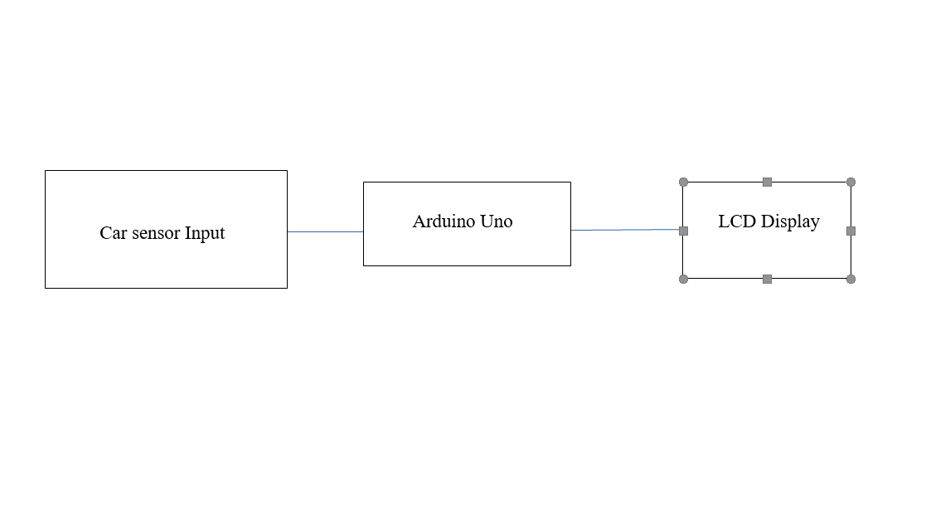 **5.2 GUI of Working System**

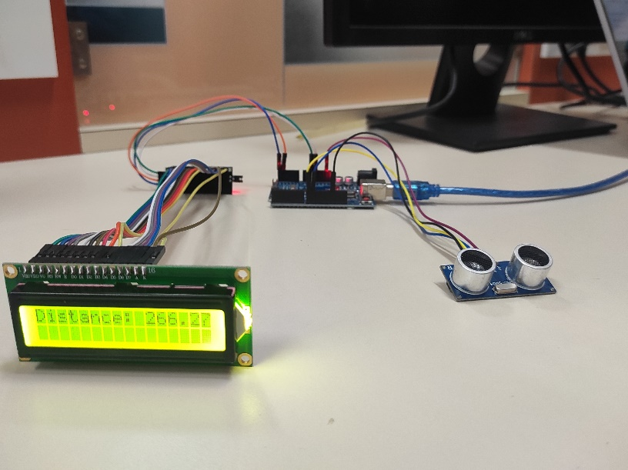

**6. Conclusion**

The objective of the project was to design and implement an ultrasonic distance meter. The device described here can detect the target and calculate the distance of the target. The ultrasonic distance meter is a low cost, low a simple device for distance measurement. The device calculates the distance with suitable accuracy and resolution. It is a handy system for non-contact measurement of distance. The device has its application in many fields. It can be used in car backing system, automation and robotics, detecting the depth of the snow, water level of the tank, production line. This device will also have its application in civil and mechanical field for precise and small measurements. For calculating the distance using this device, the target whose distance is to be measured should always be perpendicular to the plane of propagation of the ultrasonic waves. Hence the orientation of the target is a limitation of this system. The ultrasonic detection range also depends on the size and position of the target. The bigger is the target, stronger will be the reflected signal and more accurate will be the distance calculated. Hence the ultrasonic distance meter is an extremely useful device.

**7. Future Scope**

The interest for ultrasonic sensors is likewise expanding for sanitization bands as they have inbuilt closeness sensors. Implementation of a smart social distancing band using these ultrasonic sensors can be done efficiently. When a person is approaching towards us and is not maintaining 6 feet distance then the sensors can sense the person in front of us and can alert the user that the person in front of us is not maintaining social distancing. Implementation of a smart parking system with ultrasonic sensors can also be done. When an obstacle is near to the vehicle then the sensors will alert the driver that there is an obstacle at some particular distance. There are many applications where ultrasonic sensors can be used and the demand for ultrasonic sensors are increasing rapidly.

**References**

* An Ultrasonic Range Finder Designed for an Autonomous Vehicle Navigation System - by JiqiuSai 2009
* [www.ti.com/msp430](http://www.ti.com/msp430)
* <http://www.zembedded.com/interfacing-ultrasonic-rangefinder-wi>th-avr-mcus-avr-
* Ultrasonic Distance Measurement with the MSP430-Application Report- Murugavel Raju, LAA136A - October 2001
* https://arduinogetstarted.com/tutorials/arduino-ultrasonic-sensor-lcd